COM S/SE 319 : Software Construction and User Interfaces Spring 2019

HW 2

Preamble and how to run my HW

This homework is basic HTML and I haven’t added anything of major importance. The paths between files are hard coded so the only requirement is to have all the files on the same level. The files used are named
- validation1.html/.js
- validation2.html/.js
- validation.css
- wrong.png
- right.png
It shares a single CSS file to make it look decent and that is about it.

1. Validation Form 1
The fields have two tags for each, one of the form itself with a post fixed “-f” for the form tag and “-i” for the image tag. These tags are what the JS file uses to reference them. The images start with the hidden style and no source file.
When the button of validating is called, a checking function is deployed to check if all elements by id have a given value and are not empty.
The JavaScript has globals specifying the paths of the images and an array of all the forms that are due to be verified. The function iterates through these and uses the above system to pull value from the form and set the image CSS to visible. Furthermore, if it is filled it will set the source to the check, else it will set the cross.
After these are done, a function waits a window of time and redirects to the next HTML.

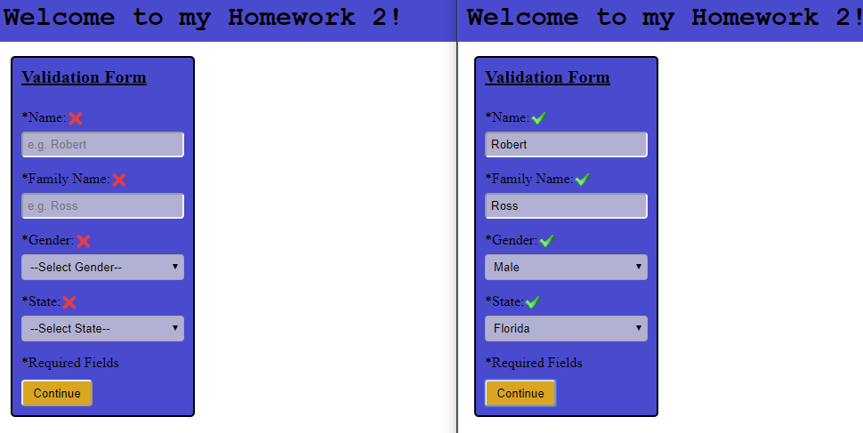

2. Validation Form 2

Next HTML uses the same system to address forms using postfixes in their id. However, this time it uses regular expressions to check against the requirements that are found in the PDF. I set up three global vars or RegEx type which have a function called test() which will return a Boolean based in if the String passed complies with the format of the regular expression that called it.
After that I do a similar process than the one that I did before. Getting the value from the field’s form tag and if it passes the RegEx check it will change the source of the image tag to reflect either check or cross.

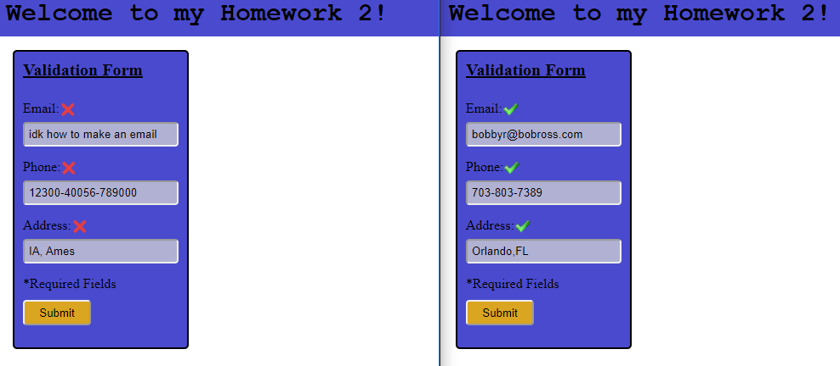

Sources Used:

- https://www.sitepoint.com/es6-arrow-functions-new-fat-concise-syntax-javascript/
- https://www.w3schools.com/js/js_timing.asp
- https://developer.mozilla.org/en-US/docs/Web/JavaScript/Guide/Regular_Expressions
- https://css-tricks.com/snippets/css/a-guide-to-flexbox/
- https://www.w3schools.com/html/html_forms.asp
- Myself; This was my internship so I knew most stuff

